First Screenshot showing what ran before doing Data and Code Dump:
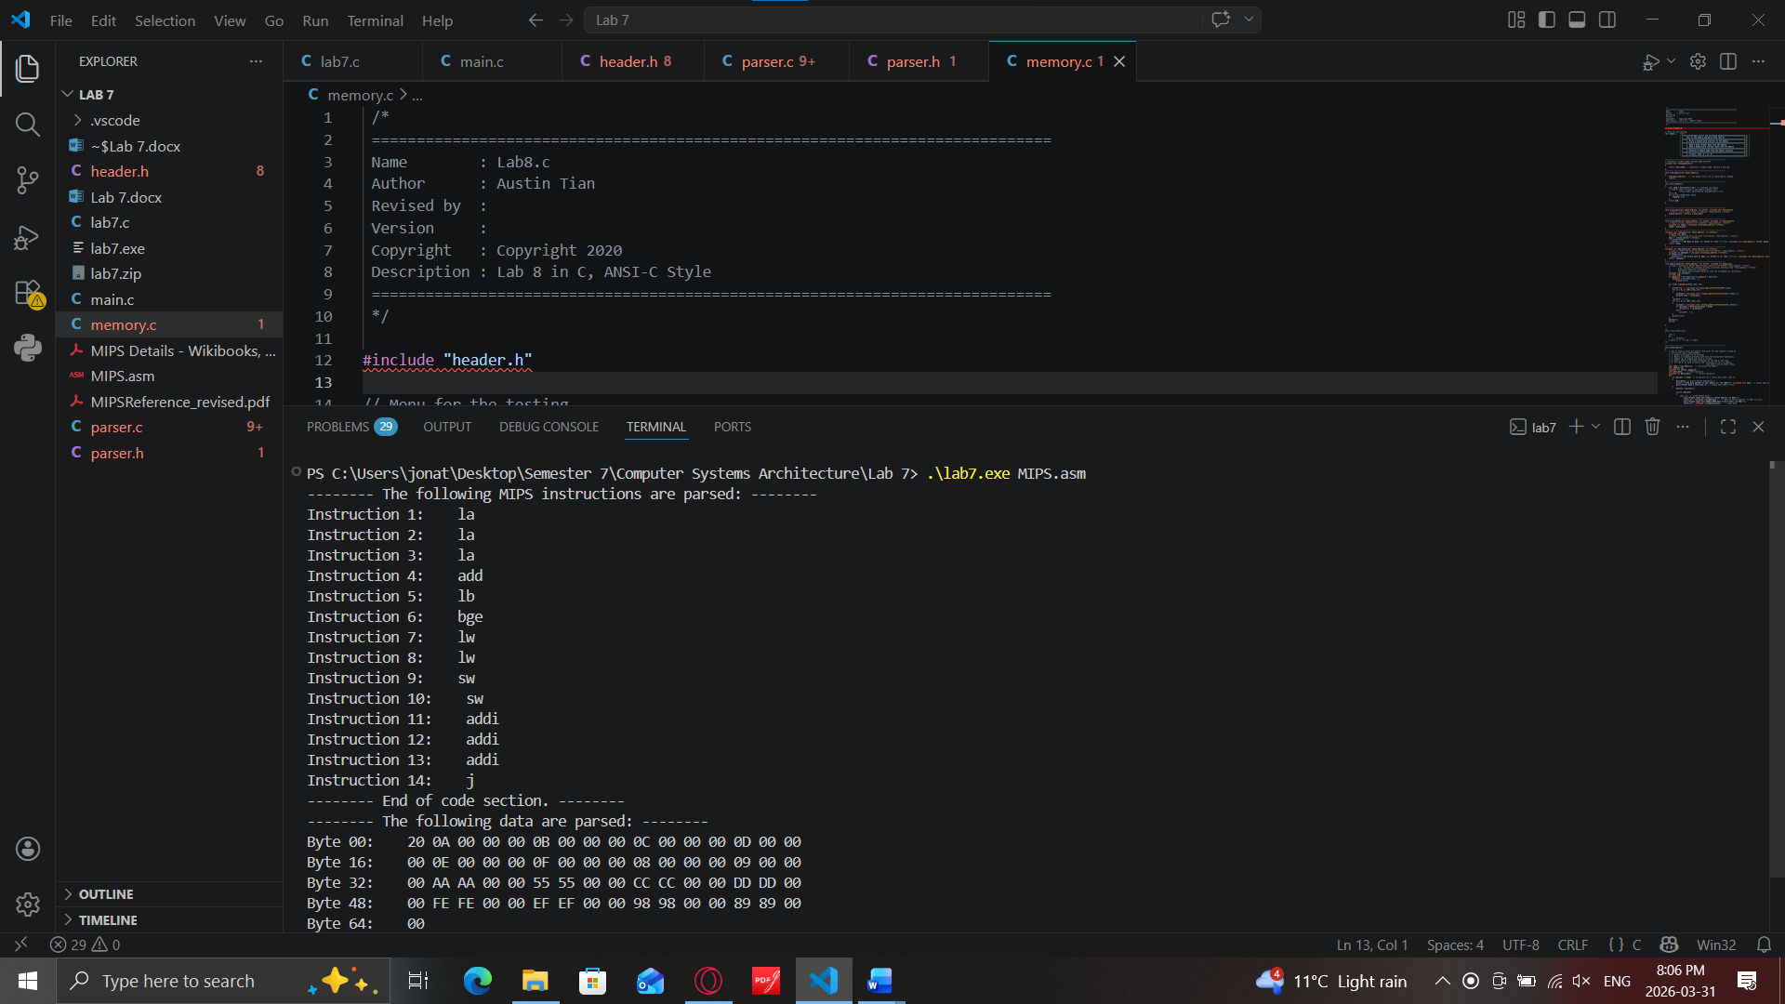

Data Section Data Dump:
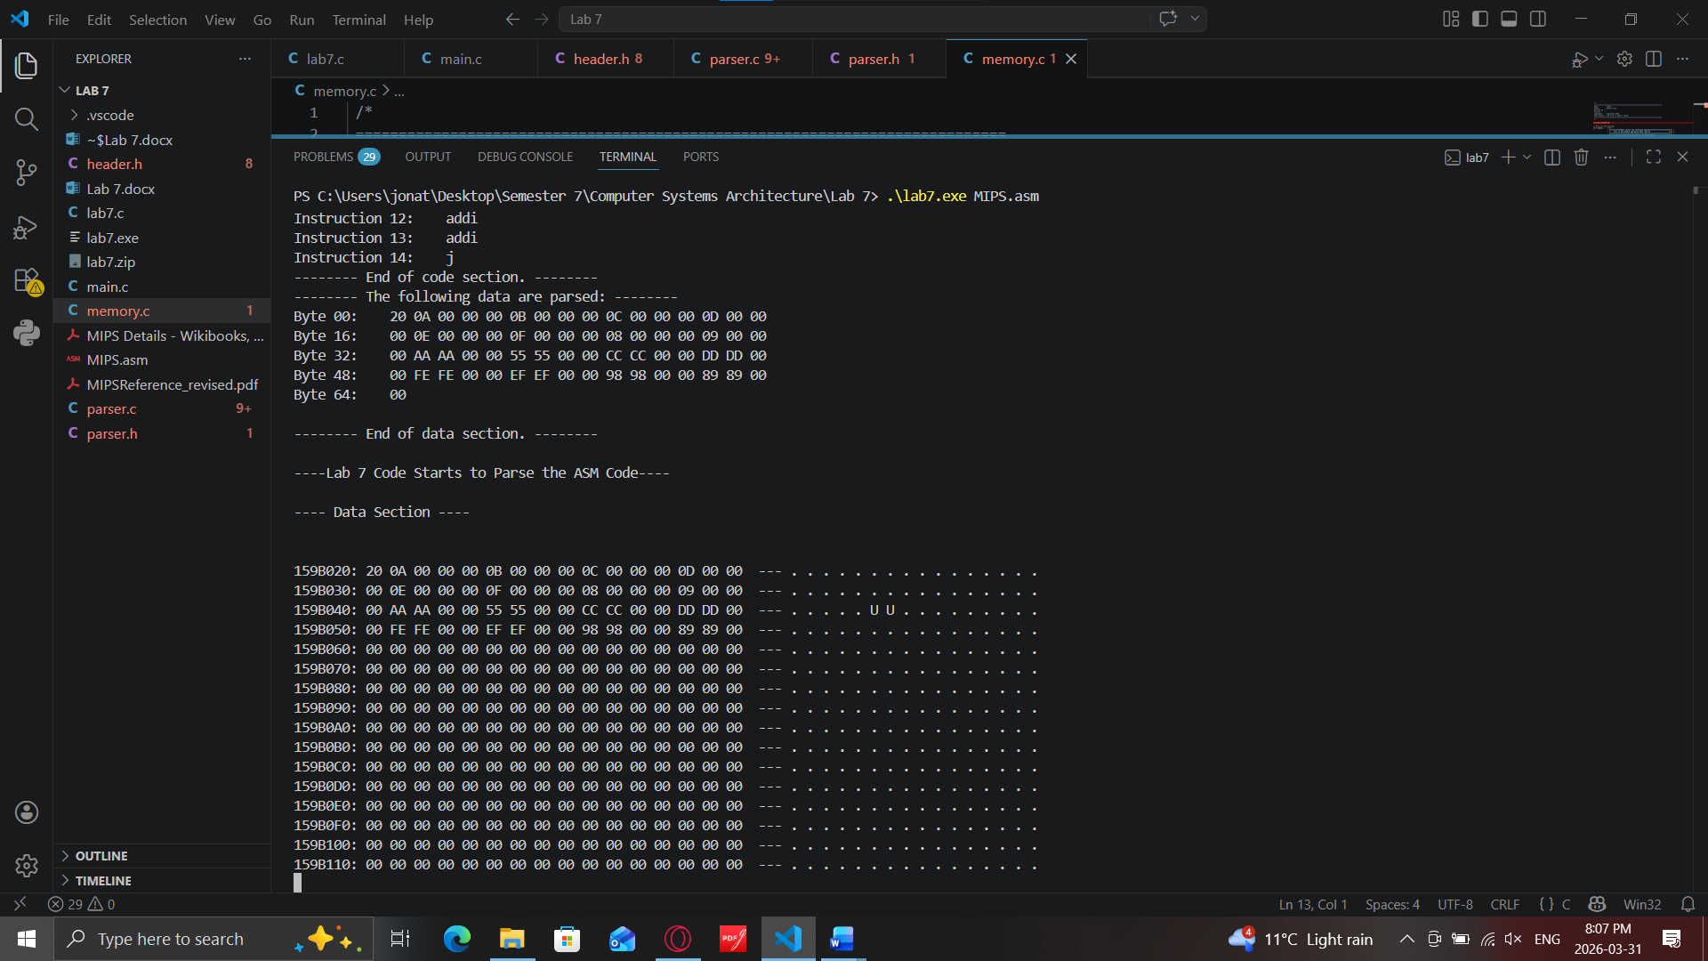

Code Section Data Dump:
